Name and Surname : Moshokoa Solomon

Module :NWAR 5122 POE

Date :20 November 2023

ST.No : ST10229897

Network Diagram:

A visual representation depicting the network's structure, including the placement of devices and data flow.

192.168.1.2

192.168.1.3

192.168.1.1

Room 1

192.168.1.4

Server Room

192.168.1.5

192.168.1.20

192.168.1.0

192.168.1.6

192.168.1.7

192.168.1.8

Room 2

192.168.2.1

192.168.1.9

192.168.1.11

192.168.1.12

192.168.1.15

192.168.2.0

192.168.1.17

192.168.2.2

192.168.1.10

192.168.1.13

192.168.1.16

192.168.1.14

Hardware and Software Components:

1. **Hardware**:
   * Server: HPE ProLiant DL380 Gen10
   * Switches: Cisco Catalyst 2960 Series (x3)
   * Routers: Cisco ISR 4000 Series (x2 for redundancy)
   * VoIP Phones: Cisco IP Phone 8800 Series
   * Wireless Access Points: Cisco Aironet 2800 Series (x4 for coverage)
   * Firewall: Cisco ASA 5500 Series
   * Backup System: Synology DiskStation DS220+
2. **Software**:
   * Operating System: Windows Server 2019
   * Network Management Software: SolarWinds Network Performance Monitor
   * VoIP Software: Cisco Unified Communications Manager
   * Security Software: Symantec Endpoint Protection

Configuration Details:

* **Server**: Configured with RAID for data redundancy, Active Directory for user management, and regular backups scheduled via Synology (Tutorials Point, 2020).
* **Switches and Routers**: Configured with VLANs for network segmentation, QoS for VoIP prioritization, and failover protocols (HSRP/VRRP) (Tutorials Point, 2020).
* **Firewall**: Configured with intrusion detection/prevention, VPN for secure remote access, and content filtering for internet usage (Tutorials Point, 2020).
* **Wireless Access Points**: Configured with WPA2-Enterprise encryption, guest network access, and coverage overlapping for seamless connectivity (Tutorials Point, 2020).

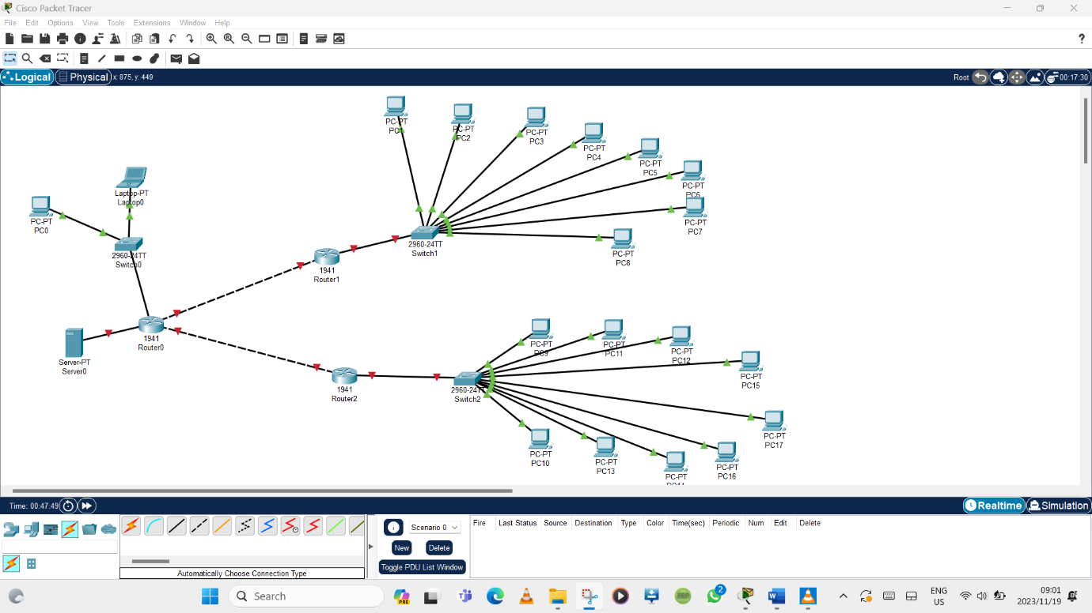

**Justification for Design Decisions:**

* **Hardware Choice**: Selection based on reliability, scalability, and compatibility with Cisco infrastructure.
* **Software Selection**: Robust solutions known for security, ease of management, and scalability (Tutorials Point, 2020).
* **Configuration Approach**: Prioritizes security, performance, and redundancy for critical components (Tutorials Point, 2020).
* **Redundancy**: Dual routers, RAID on server, and redundant switches for reliability and failover (Tutorials Point, 2020).

Meeting Business Requirements:

* **Data Storage and Backup**: Server with RAID and Synology for regular backups ensures data integrity (SDX CentraL, 2016 ).
* **Internet Access and Security**: Firewall with content filtering provides secure internet usage (SDX CentraL, 2016 ).
* **Remote Access**: VPN setup on the firewall enables secure remote access (SDX CentraL, 2016 ).
* **VoIP Communication**: VoIP phones and QoS settings ensure efficient internal and external communication (SDX CentraL, 2016 ).
* **Wireless Connectivity**: Wireless APs ensure seamless access for laptops and mobile devices.

This design integrates scalable, secure, and redundant components to meet the diverse needs of the small business, ensuring reliability, data security, and efficient communication both internally and remotely (SDX CentraL, 2016 ) (Tutorials Point, 2020).

# References

*SDX CentraL*. (2016 , February 15 ). Retrieved from https://www.sdxcentral.com/networking/sdn/definitions/networking-software/

*Tutorials Point*. (2020, Jun 17). Retrieved from https://www.tutorialspoint.com/Basic-Network-Hardware#:~:text=Basic%20Network%20Hardware%201%20Network%20Cables%20Network%20cables,5%20Gateways%20...%206%20Network%20Interface%20Cards%20